Activity | On-going activities during Covid19 pandemic | Reference Number: | OR09062020
Site | Old Registry Restaurant and Rooms | Date assessed | 09/06/2020
Location of activity | Guest Rooms, Kitchen, Dining Room, Entrance, Store, Deliveries | Expiry date | 09/06/2021
Number of people needed to undertake the task safely: |  | Varies by task requirements and working areas
Identify the level of supervision required for the activity: e.g. hourly, once during activity, other (please specify): |  | Continuous – by the Manager
At risk groups: 1 - Employees 2 – Contractors 3 - Visitors 4 - Public 5 – Apprentices /Trainee

Task Sequence |  | At Risk Groups |  | Hazards Identified | Potential effect from the hazard |  |  | Company Procedure  (Controls, equipment, working methods - Eliminate/Reduce/Isolate/Control/PPE) |  |  |  |  |  |  | Severity | Likelihood | Risk
Determining suitable areas of the business to commence / continue works |  | 1,2,3,4 |  | General Personal Interaction | Unintentional spread of Covid19 |  |  | - Management to carry out a pre-review of all areas to determine any necessary steps to be implemented to ensure compliance.  - Only commence or continue work once standard operating procedure to provide social distancing and hygiene in accordance with current UK government guidelines are in place.  - Continual monitoring of internal controls to effectively deliver the service standard.  - Provide adequate PPE for all staff including re-supply stocking levels suitable for every task  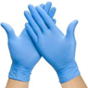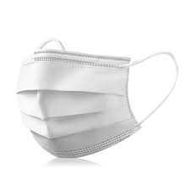  - Washing stations to be provided with suitable hand wash, and sanitiser.  - Conduct communications remotely (e.g. by phone, email) where practical.  - Where face to face contact is required to maintain social distancing and hygiene in accordance with current UK government guidelines, for example:  - Hold face to face contact in outdoor/open environment  - Maintain 1m distance from others  - Avoid interaction with members of the public where possible.  - Where contact is required act professionally and maintain 1m social distancing.  - Where members of the public are confrontational and do not maintain social distancing notify your Responsible Manager for reporting to the police. |  |  |  |  |  |  | 5 | 1 | M
 |  |  |  |  | Breach of Government Guidance
 |  |  |  | Poor Mental Wellbeing | Stress and Financial Certainty |  |  | - Provide regular and accurate updates about the impact of Covid-19, with all employees regularly.  - Promote Employee support.  - Maintain meaningful work and normal income for as long as it is safely practicable.  - Support those who need time off work because of illness, caring for others. |  |  |  |  |  |  | 5 | 1 | M
Travelling to and from work |  | 1, 2,3 |  | General Personal Interaction | Unintentional spread of Covid19 |  |  | - Avoid interaction with members of the public where possible.  - Where contact is required act professionally and maintain 1m social distancing, 2 I s preferred .  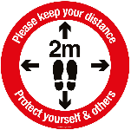  - Where members of the public are confrontational and do not maintain social distancing notify the driver for reporting to the police.  - Vehicle touch points (e.g. door handles, steering wheel) to be regularly cleaned with soap and warm water. |  |  |  |  |  |  | 5 | 1 | M
 |  |  |  | Interaction with person developing coronavirus symptoms |  |  |  | - Anyone feeling unwell to report condition to the manager by phone and do not attend work.  - Any employee who has been in contact with anyone who has the symptoms must self-isolate with immediate effect  - Recommended action to follow government guidelines on testing.  - Request the thorough clean with disinfectant any personnel vehicle an unwell person may have travelled in – recommend to isolate / do not use the vehicle until it has been thoroughly cleaned, RPE and Gloves are worn during cleaning. |  |  |  |  |  |  | 5 | 1 | M
Engaging with Suppliers and other stakeholders |  | 1,2,3,4 |  | General Personal Interaction | Unintentional spread of Covid19 |  |  | - Conduct communications remotely (e.g. by phone, email) where practical.  - Where face to face contact is required to maintain social distancing and hygiene in accordance with current UK government guidelines, for example:  - Hold face to face contact in outdoor/open environment  - Maintain 1m distance from others, 2 preferred  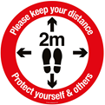  - Avoid interaction with members of the public where possible.  - Where contact is required act professionally and maintain 2m social distancing. Where members of the public are confrontational and do not maintain social distancing notify your Responsible Manager for reporting to the police.  - Deliveries of goods –all deliveries to be dropped off in an allotted area to allow disinfecting of packaging and if feasible allow the package to be untouched in a closed room for 72 hours if possible before use.  - All packing removed from goods must be disposed of immediately  - Hand Washing for a minimum of 20 seconds must be carried out after each time contact with any materials as occurred.  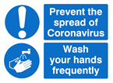  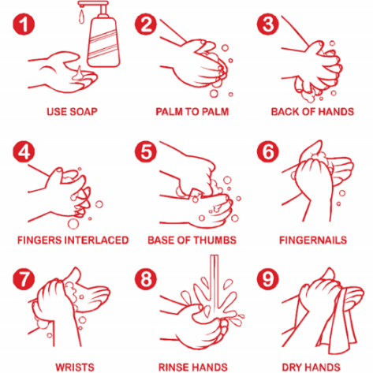 |  |  |  |  |  |  | 5 | 1 | M
 |  |  |  |  | Breach of Government Guidance
Briefing works and safety information to Employees & Guests |  | 1,2 |  | General Personal Interaction | Unintentional spread of Covid19 |  |  | - Works and Safety Information to be essential information only – avoid communicating general or non-critical information.  - Guidance on safe ty procedures will eb provided to all employees on what steps must be taken to ensure compliance with this Risk assessment  - Works and Safety Information to be delivered by a Responsible Person to groups no more than two or three people at a time in outdoor/open environment.  - Maintain 1m distance from others during briefings, 2 meters is preferred  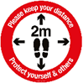  - Wear gloves and use your own pen to sign documentation  - Guidance and relevant Signage to be placed in each room |  |  |  |  |  |  | 5 | 1 | M
 |  |  |  |  | Breach of Government Guidance
General operations standards |  | 1,2,3 |  | General Personal Interaction | Unintentional spread of Covid19 |  |  | - Maximise and maintain working distances between different site operations – planning,  - Wear gloves always. Gloves to be regularly cleaned or replaced where worn through and avoid contact with the face.  - Wash your hands with soap and warm water for at least 20 seconds as often as possible.  - Maintain a 1-metre minimum distance from other workers, 2 meters is preferred.  - Specific tasks such as cleaning, kitchen duties, service ideally one employee per task. Where that is not possible, touch points (door handles, equipment, etc.) shall be thoroughly cleaned with disinfectant between uses by different staff.  - Use of Toilet facilities for both staff and guests:  - Use provided sanitiser dispensers and wipes.  - Personal hygiene is especially important in these areas.  - Always wash your hands when you get home or arrive at work.  - View the site COVID-19 Notice Board daily for new information and guidance. Adhere to signage and poster information as applicable.  - Use hand sanitiser gel if soap and water are not available.  - 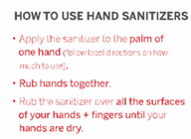  - Cover your mouth and nose with a tissue or your sleeve (not your hands) when you cough or sneeze.  - Put used tissues in the appropriate bin immediately and wash your hands afterwards.  - Do not touch your eyes, nose, or mouth without washing your hands first. |  |  |  |  |  |  | 5 | 1 | M
 |  |  |  |  | Breach of Government Guidance
General operations deliveries and collections |  | 1,2,3 |  | General Personal Interaction | Unintentional spread of Covid19 |  |  | - Verbal communication with staff and guests to be kept to a minimum.  - Always maintain a 2-metre minimum distance apart  - Where material suppliers do not need you to sign their ticket then do not touch them.  - Photograph delivery notes instead of handling them.  - Where tickets need to be signed wear gloves so no bare hand to hand transmission of material tickets.  - Employees use their own pen where tickets need signing – do not use drivers pens. Receipt of all deliveries including post, employees need to wash their hands very frequently and pay strict adherence to government guidelines on hand washing.  - Where tickets are transmitted put them in an envelope for passing to the Manager.  - Do not seal envelopes which require a lick to seal. |  |  |  |  |  |  | 5 | 1 | M
 |  |  |  |  | Breach of Government Guidance
General operations – Kitchen & Restaurant staff |  | 1,2,3 |  | General Personal Interaction | Unintentional spread of Covid19 |  |  | - Works shall only proceed where this method of work and risk assessment is approved  - Tables to be placed to ensure 1m distancing is in place, 2 meters is preferred where possible  - Provide suitable signage to show established routes, a one-way system will operate in dining room to reduce customer contact  - Disinfectant tables and lamps, candle stick in between use  - Tables will be cleared of all used items and removed to the kitchen to enable thorough cleaning.  - Maximise and maintain working distances between different areas of the kitchen and the restaurant when possible  - Face shield to be worn where close contact with customers is unavoidable  - Staff should have their own sanitiser, pens & order pads at all times. If you lose your pen etc, a new pen should be cleaned before use.  - The toilets will be one in one out, with no waiting in the stairwell. A sign system will be in operation to tell guests when the cubicle is free.  - Kitchen staff will work in their own areas, and back to back where possible.  - Food will be dished up and then the chef to stand back while the waiting staff take the food from the serving area.  - Food, drinks orders and payments will all be served & taken at the table at the table, no standing at the bar for any reason.  - Toilets will be checked & cleaned every hour  - One member of staff should be designated for each task that shift, to include dessert preparation, wine collection form cellar, food collection form garage area, cleaning toilets, washing up, serving drinks, serving food,  - Wash your hands with soap and warm water for at least 20 seconds as often as possible using the wash basin supplied.  - Maintain a 1-metre minimum distance from other workers.  - Specific tasks such as cleaning, kitchen duties, service ideally one employee per task. Where that is not possible, touch points (door handles, equipment, etc.) shall be thoroughly cleaned with disinfectant between uses by different operators.  - Maximum restaurant numbers is 30, after this number entry is refused.  - Music should be played low, this is to prevent shouting & raised voices which can increase distance of droplets expelled from the mouth.  - Customers with children should supervise at all times, and children should stay seated at all times. |  |  |  |  |  |  | 5 | 1 | M
 |  |  |  |  | Breach of Government Guidance
General operations – Room & general Cleaning staff |  | 1,2,3 |  | General Personal Interaction | Unintentional spread of Covid19 |  |  | - Works shall only proceed where this method of work and risk assessment is approved.  - Disinfectant cleaning solution and spray will be used on all areas in the rooms.  - Maximise and maintain working distances in the rooms.  - PPE – Gloves must be changed and disposed of once a room as been cleaned for the next guest  - If Gloves are worn, they should be regularly cleaned or replaced where worn through and avoid contact with the face.  - Wash your hands with soap and warm water for at least 20 seconds as often as possible using the wash basin supplied.  - 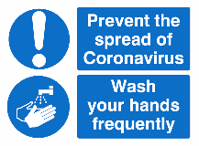  - Maintain a 1-metre minimum distance from other workers.  - Specific tasks such as cleaning, kitchen duties, service ideally one employee per task.  - Where that is not possible, touch points (door handles, equipment, etc.) shall be thoroughly cleaned with disinfectant between uses.  - All guest keys to be disinfected after the guest has checked out. |  |  |  |  |  |  | 5 | 1
 |  |  |  |  | Breach of Government Guidance
General operations –Staff welfare |  | 1,2,3 |  | General Personal Interaction | Unintentional spread of Covid19 |  |  | - Wash hands at break times before and after eating or drinking.  - Wash your hands with soap and warm water for at least 20 seconds as often as possible using the wash basin supplied.  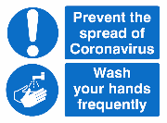  - Welfare areas to be thoroughly cleaned regularly with soap and warm water.  - Bag all used uniforms separately to avoid contamination with others.  - Uniforms, hand towels etc will be washed utilising the highest temperature washing setting at work to reduce contamination. |  |  |  |  |  |  | 5 | 1 | M
 |  |  |  |  | Breach of Government Guidance
Emergency Response situations |  | 1,2,3,4 |  | General Personal Interaction | Unintentional spread of Covid19 |  |  | - Follow site Emergency Response as far as social distancing allows.  - Differences for dealing with medical incidents are:  - If the Injured Person can self-administer first aid get them to do this under First Aider supervision.  - If someone feels unwell during a shift with coronavirus symptoms isolate them as far away from others as possible. If they are not well enough to drive themselves home contact someone, they would be self-isolating with to arrange collection.  - Follow Resuscitation Council UK guidance when administering CPR. |  |  |  |  |  |  | 5 | 1 | M
 |  |  |  |  | Breach of Government Guidance
Low | Proceed  Follow the RA controls |  |  |  |  |  | Medium |  | Proceed with caution  Follow the Company controls & RA |  | High |  | Stop - Do not proceed  RA must be reviewed
Name(s) of Assessor(s) |  |  | Leanne Quinn |  |  | Date reviewed: |  |  |  | 09/06/2020 |  | Next Review date: |  | 09/06/2021
Risk Rating Matrix
 | H&S impacts
SEVERITY | Fatality Disability |  | 5 | M |  | H |  | H |  |  |  |  | H |  |  | H
 | Serious Injury |  | 4 | M |  | M |  | H |  |  |  |  | H |  |  | H
 | Medical Treatment /  Major Collision |  | 3 | L |  | M |  | M |  |  |  |  | H |  |  | H
 | First Aid /  Minor collision |  | 2 | L |  | L |  | M |  |  |  |  | M |  |  | H
 | Near Hit |  | 1 | L |  | L |  | L |  |  |  |  | M |  |  | M
Risk = Severity x Likelihood |  |  | 1. Extremely unlikely |  |  | 2. Unlikely |  | 3. Possible |  |  |  |  | 4. Likely |  |  | 5. Highly Likely
Likelihood
Risk Colour Code: -
Low Risk |  | Proceed following additional controls
Medium Risk |  | Proceed with caution following the implemented controls
High Risk |  | Stop - Do not proceed. Current Controls must be reviewed.

Serious Injury: An injury for which a person is detained in hospital as an “in-patient”, or any of the following injuries whether or not they are detained in hospital: fractures, concussion, internal injuries, crushing injuries, burns (excluding friction burns), severe cuts, severe general shock requiring medical treatment.

